Referee report:

“Physics of Light Mesons”: project PEN-MEG

One of the key assumptions of the standard model (SM)of particle physics is that the interactions of the charged leptons, namely electrons, muons and taus, differ only because of their different masses. In the SM all charged leptons, such as taus (τ) or muons (μ), interact in an identical fashion (have the same "couplings"). This property is called "lepton universality". However, differences in mass between the leptons must be accounted for. Whereas precision tests comparing processes involving electrons and muons have not revealed any definite violation of this assumption. A confirmation of these results would point to new particles or interactions, and could have profound implications for our understanding of particle physics.

One of such precision measurements, in the lepton sectors, to investigate these effects was conducted the PSI using the MEG-PEN experimental systems that ran from 2010-2015 and is presented in this report.

The PEN detector:this involves precise measurements ofπ→ e ν branching ratios, which ran for data taking during the period of 2008,2009 and 2010.The JINR team made a major contribution to a variety of sub-detector systems such as the cylindrical wire chamber, CsI crystals for the calorimeter, the DAQ system and data analysis.The analysis of the PEN systems required measurements of the decay histograms of the π→ e ν and π→ μ→e sequence. Both events ensembles were obtained with minimal requirements on detector observable – none of which biases the selection in ways that could affect ratios. During this period PEN accumulated 23 and1.5 million events for the π→ e ν and π→ μ→eprocesses, respectively, as well as significant numbers of muon and pion radiative decays. At the time of presenting the report, the authors note that there appears to be no obstacles that would prevent PEN collaboration to reach a precision ΔR/R<10⁻³.

The MEG Experiment searches for a lepton flavour violating muon decay,µ⁺→e⁺γ, with a branching ratio sensitivity of 10⁻¹³ in order to explore the parameter region predicted by many theoretical models beyond the Standard Model. The COBRA spectrometer is used to stop high-energy muons, which decay at rest into two monochromatic back-to-back electron and gamma ray signals as depicted in the figure below. Sophisticated algorithms are applied in the extraction of single muon/photon signals from the Michele and radiative background processes.
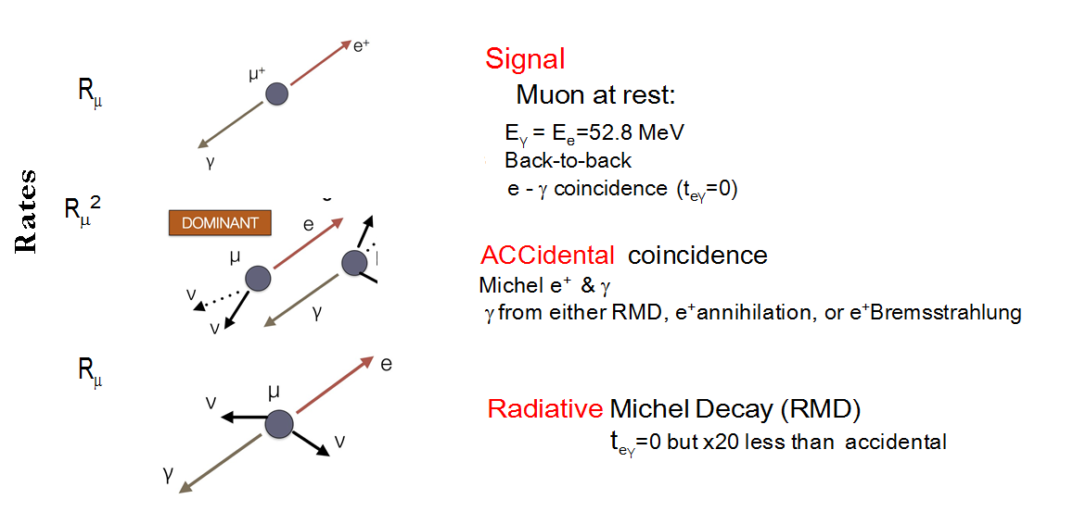
No significant excess of events is observed in the dataset with respect to the expected background in the final analysis of 7.5 × 10¹⁴ muons stopped in the COBRA target. Another result reported on a new upper limit on the branching ratio of the decay of B(μ+ → e+γ) < 4.2×10⁻¹³ (90% confidence level), which represents the most stringent limit on the existence of this decay to date.The data showed consistency with SM of the residual muon polarization, which was found to be P^{μ} = −0.86 ± 0.02 (stat) (+0.05/−0.06)(syst).

The results stated above, provided the motivation for the extension of the study to improve on them by proposing MEG-II experiment, which seeks to look into the lepton-flavour violating decay (cLFV) µ⁺→e⁺γ where an improvement, by an order magnitude, of sensitivity is expected. Among the improvements in the setup is the new highly segmented, fast timing counter array with improved timing resolution capabilities that will minimize the background events entering the timing window. Moreover, the photon arm in form of the liquid xenon will be largest of its kind and this will also help improve granularity by replacing the PMT system with smaller photo sensors - thereby increasing the energy and spatial resolution of the system.

All these improvements will result in the experiment being able to reach the discovery capabilities of the MEG system and thus play a key role in addressing some of the most topical, and unanswered questions, and set limits on some of the assumptions of the standard model of particle physics. The JINR team has acquired expertise over the past few years to manage this undertaking for this project which will run from 2018-2020. They have an excellent base built on the PEN-MEG to achieve this goal. The budgets assumptions seem reasonable. I strongly support this proposal.

Zeblon Z Vilakazi

12thJune 2017

